Steps to making my pipeline
1. Create my source and target buckets
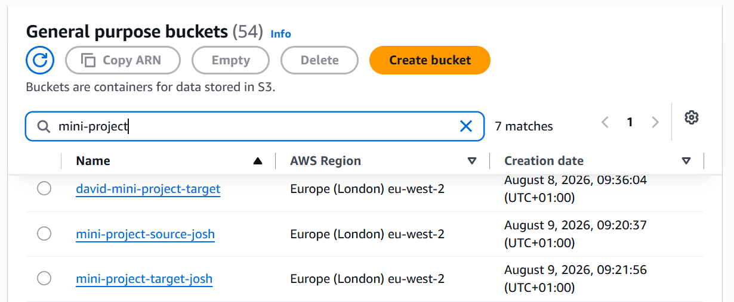
2. change IAM roles so we can get objects (Possible to do this in the bucket settings, for sake of practice I am using IAM)
2a. provide IAM with lambdas basic execution role so it can interact with cloudwatch first
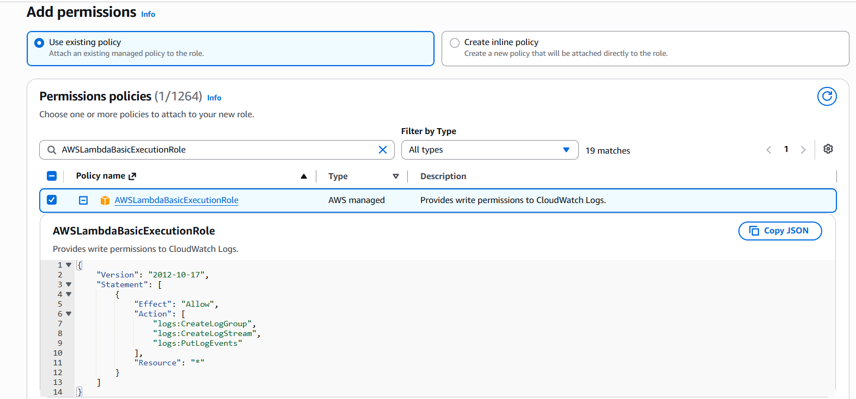
2b. give lambda permission to put and receive objects from our buckets
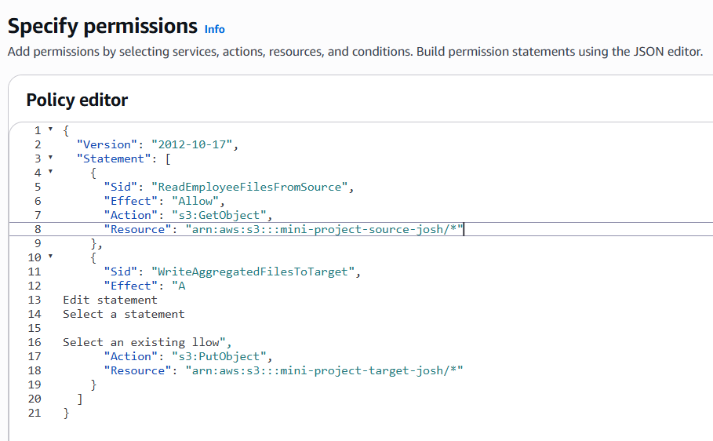

3. implement lambda:
3a. create lambda and attach IAM policy
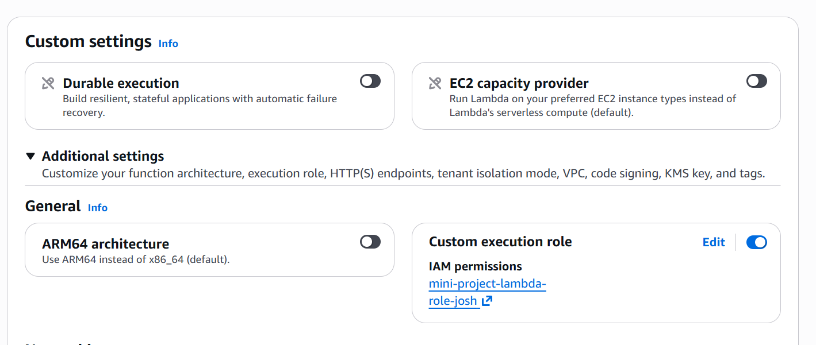
3b. edit environment details so it is attached to the target bucket
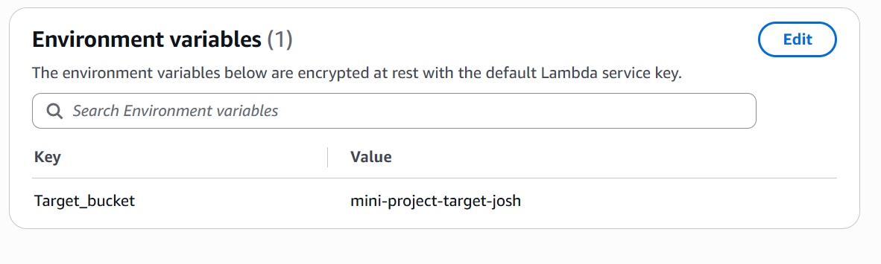
3c. add code to lambda to give it functionality
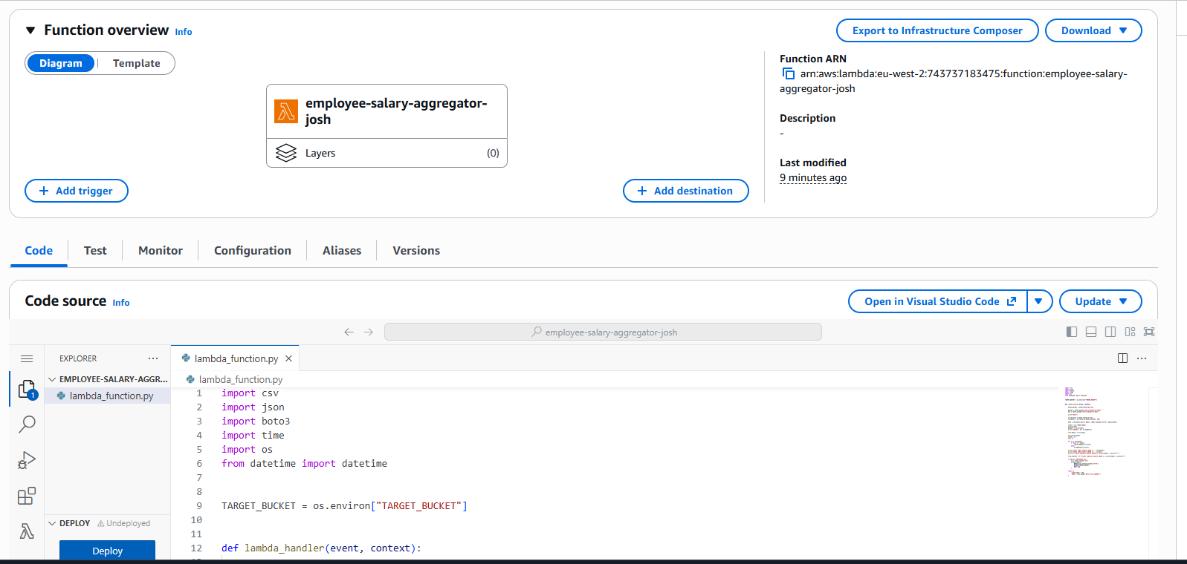
3d. adjust configurations so timeout is where I want it
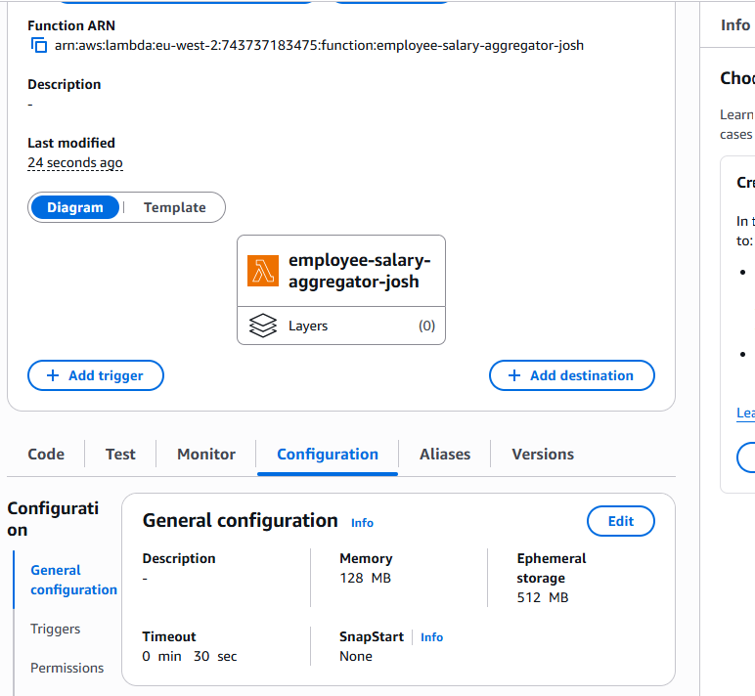
4. Create + add trigger
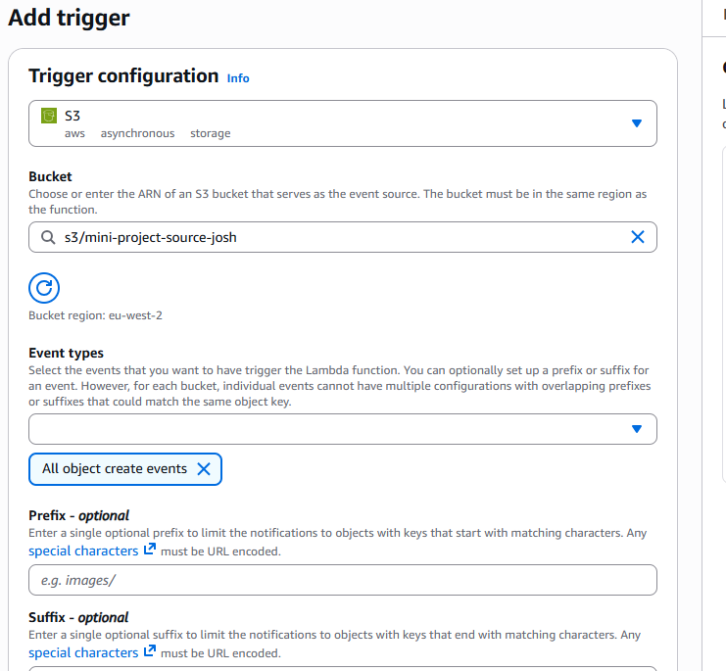
5.upload data onto s3 source bucket
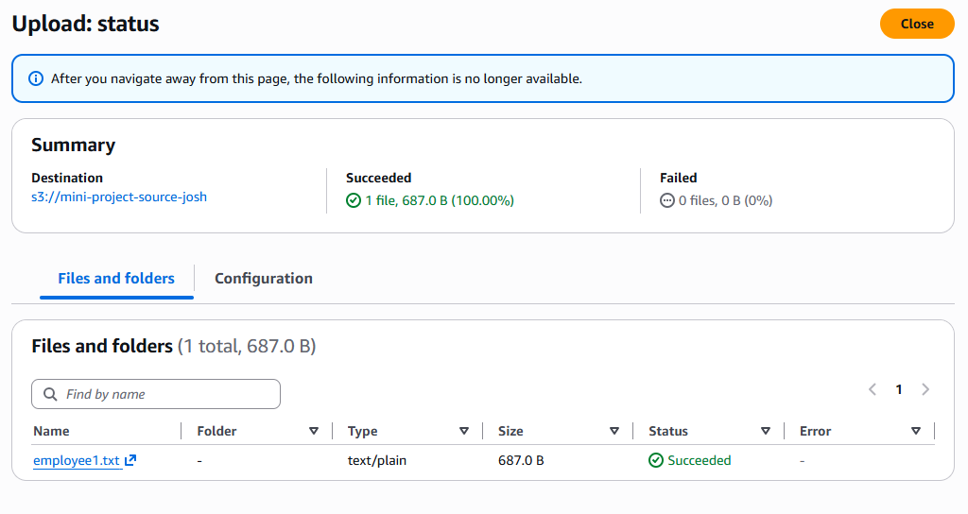
6. check target bucket for output:
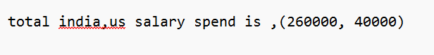
7. Check logs
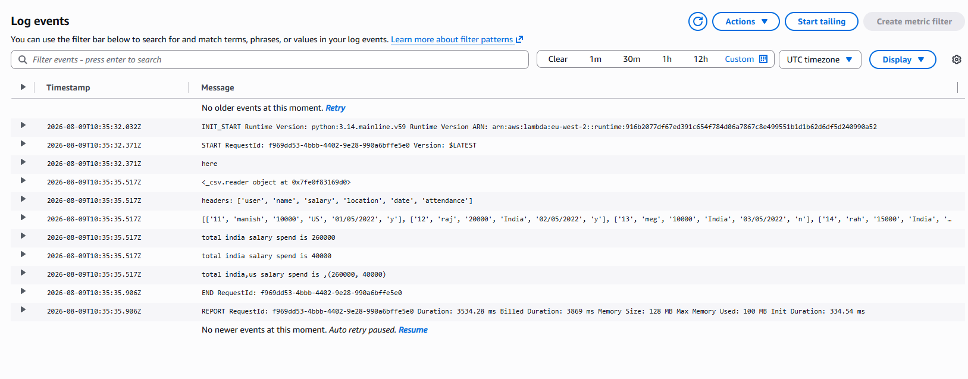

Changes I made to code:
Added: import os
Added: if key in ('employee1.csv', 'employee1.txt'): so that both csv and txt files can be accepted
Changed file and bucket names

